Hypothesis 2 - Body-axis alignment vs distance to source
Mouse Arena trajectory analysis - pooled Loc1-6 (n = 105 trials)

1. Goal and hypotheses
Goal: test whether the mouse's body axis becomes better aligned toward the odor source as it approaches, using the absolute body-axis-to-source angle theta as a function of distance-to-source d.
H2: theta decreases as the animal approaches the source - equivalently, theta INCREASES with distance-to-source d, so the per-trial OLS slope of theta on d is positive (better alignment when closer).
H0: theta is independent of d (zero per-trial slope).
Accept H2 iff (a) per-trial slopes are significantly > 0 (Wilcoxon signed-rank) AND (b) the F3 binned curve rises with distance. Direction is reported before significance throughout.

2. Methods
Data access. Trials were read through the shared accessor and traj_common pipeline (traj_common/1.0) from the aggregate file C:\Projects\Repos\Mouse Arena\DATA\Mouse Arena Aggregate Data.h5. Analyses were run with the project interpreter (vras). Random seed = 1234 for all bootstraps.
Geometry / angle convention. For each kept head-clock frame, the body axis is u = unit(head - body) and the to-source direction is s = unit(endpoint - body). The absolute angle between them, theta = arccos(u . s), lies in [0, 180] degrees; small theta means the body axis points toward the source.
Per-trial statistic. For each trial we fit an ordinary-least-squares (OLS) slope of theta(t) on d(t) over the kept frames of the body track. A positive slope means theta is larger when farther away (better alignment when closer), which is the H2-predicted direction.
Group test. Across the 105 pooled Loc1-6 trials (replication unit = trial), a Wilcoxon signed-rank test (alternative = 'greater') asks whether the per-trial slopes are > 0. The median slope with a 95% bootstrap CI (2000 resamples over trials) is reported for direction and effect size.
F3 binning (D9). Distance-to-source was binned in fixed 20-px bins from 0 to the max observed distance on the body track; per bin we report the mean of theta pooled over all in-bin samples across trials, shaded with a 95% CI (bootstrap over trials, seed 1234), requiring >= 30 samples per plotted bin.

3. Results
Direction. The per-trial slopes are POSITIVE in direction: median slope = +0.0202 deg/px (95% bootstrap CI [+0.0009, +0.0432]), the sign predicted by H2.
Significance. The Wilcoxon signed-rank test (slopes > 0) is NOT significant: W = 3151.0, p = 0.119 (n = 105, trial). At alpha = 0.05 the null of zero/negative slope is not rejected.
Per-trial slope distribution: of 105 trials, 64 have positive slopes and 41 negative (0 exactly zero); slopes range from -0.4205 to +0.1662 deg/px. The effect is a modest population-level tendency, not driven by a handful of trials.
H2 is NOT supported at alpha = 0.05. The per-trial slopes trend in the predicted (positive) direction but do not reach significance, and the F3 binned curve does not rise monotonically with distance (see below).

3.1 Figure F3 - Alignment vs distance to source
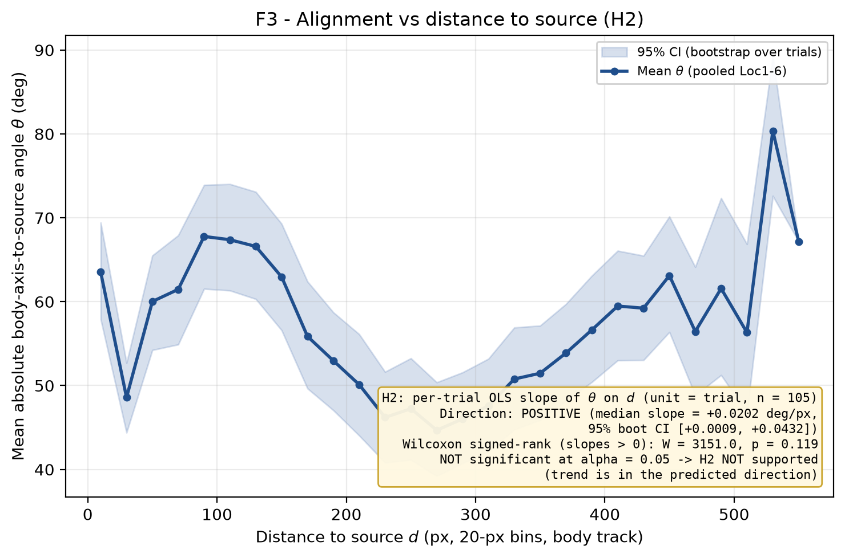
Figure F3. Mean absolute body-axis-to-source angle theta (deg) vs distance-to-source d (px), pooled Loc1-6. Distance binned in 20-px bins on the body track (>= 30 samples/bin); shaded band is the 95% bootstrap CI over trials (n_boot = 2000, seed 1234). Annotation gives the H2 per-trial-slope Wilcoxon result (W = 3151.0, p = 0.119) and the median slope (+0.0202 deg/px, 95% CI [+0.0009, +0.0432]). Under H2 the curve should fall with distance in theta if alignment improves when closer; note the curve is non-monotonic.
Reading the stored F3 curve: theta = 63.5 deg at the nearest bin (d = 10 px), reaches a minimum of 44.7 deg at d = 270 px and a maximum of 80.4 deg at d = 530 px, and is 67.2 deg at the farthest well-sampled bin. The curve is non-monotonic (it does not rise steadily with distance), so the F3 rising criterion for accepting H2 is not clearly met.

3.2 F3 binned curve (values plotted)
d (px) | mean theta (deg) | CI lo | CI hi | n trials | n samples
10 | 63.54 | 57.91 | 69.42 | 67 | 44892
30 | 48.58 | 44.39 | 52.70 | 100 | 83375
50 | 60.02 | 54.23 | 65.50 | 102 | 71108
70 | 61.47 | 54.89 | 67.91 | 102 | 60102
90 | 67.78 | 61.53 | 73.91 | 102 | 66035
110 | 67.39 | 61.33 | 74.02 | 103 | 79505
130 | 66.59 | 60.32 | 73.09 | 103 | 70222
150 | 62.95 | 56.59 | 69.28 | 103 | 58983
170 | 55.86 | 49.65 | 62.40 | 104 | 56783
190 | 52.97 | 47.05 | 58.73 | 104 | 68374
210 | 50.11 | 44.04 | 56.12 | 105 | 27093
230 | 46.20 | 40.82 | 51.63 | 104 | 21902
250 | 47.25 | 41.17 | 53.25 | 104 | 29625
270 | 44.68 | 39.22 | 50.38 | 104 | 23129
290 | 46.03 | 40.75 | 51.57 | 103 | 29726
310 | 47.59 | 42.17 | 53.19 | 103 | 18938
330 | 50.78 | 44.76 | 56.92 | 103 | 20088
350 | 51.47 | 45.89 | 57.14 | 103 | 18525
370 | 53.88 | 48.22 | 59.72 | 103 | 21067
390 | 56.64 | 50.41 | 63.09 | 103 | 21481
410 | 59.48 | 53.00 | 66.07 | 103 | 26587
430 | 59.23 | 53.03 | 65.48 | 102 | 75478
450 | 63.11 | 56.38 | 70.15 | 89 | 71059
470 | 56.45 | 48.83 | 64.14 | 72 | 20977
490 | 61.58 | 51.25 | 72.35 | 57 | 74696
510 | 56.32 | 46.76 | 66.87 | 45 | 23830
530 | 80.37 | 72.61 | 89.27 | 4 | 1502
550 | 67.17 | 67.17 | 67.17 | 1 | 65

4. Caveats and limitations
- Angle convention verified in Gate 1: a near-source trial gave theta ~ 23 deg (a trial visibly facing the port yields small theta), confirming u = unit(head - body) and s = unit(endpoint - body).
- Single cohort, infrared recording, distances in pixels (uncalibrated to physical units); results are within-cohort and not cross-validated.
- Direction before significance: the slope sign is positive (H2 direction) but the Wilcoxon test is not significant (p = 0.119); we do not over-claim an effect.
- Per-test 95%% CIs are reported with no family-wise correction across H1-H3; interpret p-values accordingly.
- The two farthest bins are sparsely populated by trials (few trials reach the largest distances), so the far end of the F3 curve is less reliable even where per-sample counts meet the >= 30 threshold.

5. Reproducibility
All numbers above are injected from data/stats.json (H2 block); no value was typed by hand. Stats created_utc = 2026-08-08T04:40:54Z; seed = 1234; traj_common = traj_common/1.0; n_boot = 2000.
Result files:
- data\stats.json (H2 block; source of every number)
- data\trajectory_metrics.json / .h5 (per-trial h2_slope attribute)
- reports\figures\F3_angle_vs_distance.png / .pdf / .txt
- reports\H2 - alignment vs distance.docx (this report)
Reproduce (from the trajectories base dir):
AR_PY="C:/Projects/Repos/Agentic Research/Research Setup/vras/Scripts/python.exe" ; "$AR_PY" code/make_F3.py ; "$AR_PY" code/make_H2_report.py

